JavaScript Event Handling Examples

1. Button Click Event (onclick)
<button onclick="showMessage()">Click Me</button>
<script>
function showMessage() {
alert("Button Clicked!");
}
</script>

OUTPUT:
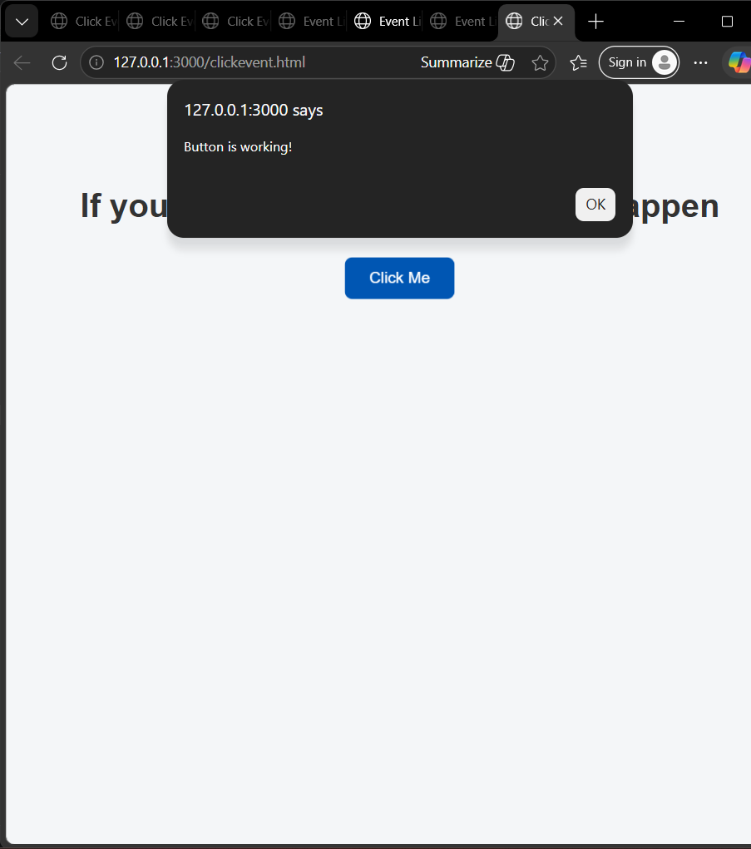

2. Show Input Value While Typing (oninput)
<input type="text" id="name" oninput="showText()" placeholder="Type something...">
<p id="output"></p>
<script>
function showText() {
let value = document.getElementById("name").value;
document.getElementById("output").textContent = value;
}
</script>
OUTPUT:
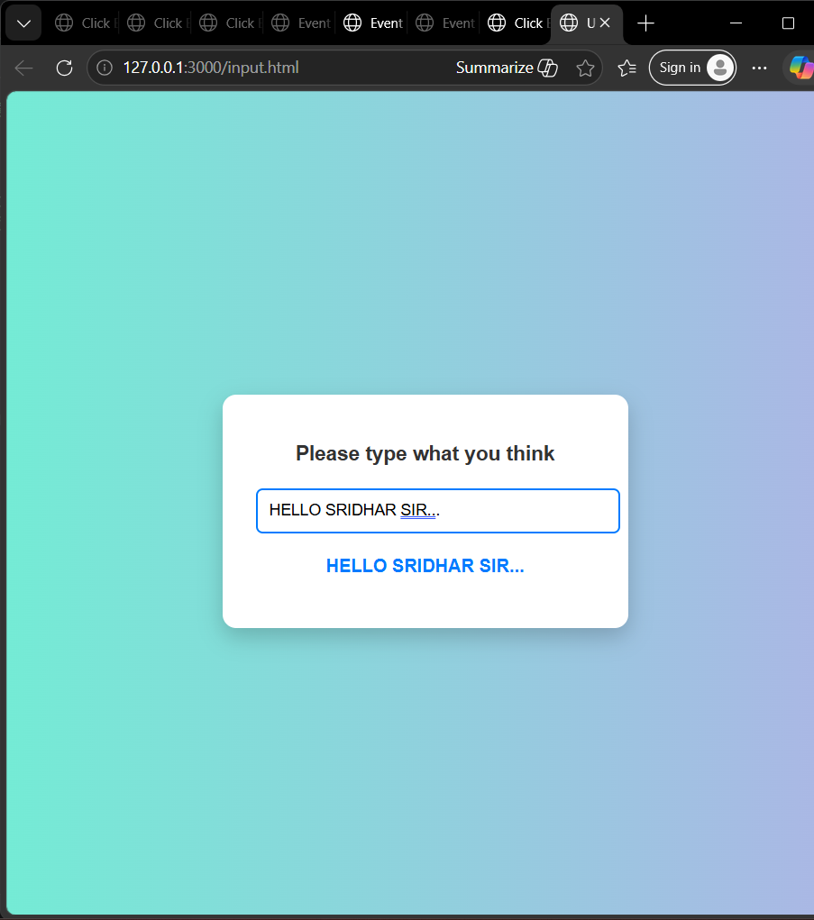

3. Add Event Listener to a Button
<button id="btn">Click Me</button>
<script>
let button = document.getElementById("btn");
button.addEventListener("click", function() {
alert("Button Clicked using addEventListener!");
});
</script>

OUTPUT:
